**Congratulations on being selected for round 2!**

You’ve been asked to implement a prototype of a visual object detection system for your next round.

TASK DESCRIPTION

The task is to find a location of a phone dropped on the floor from a single RGB camera sample. There is only one type of phone we are interested in detecting.

Example of an image with a phone on it.

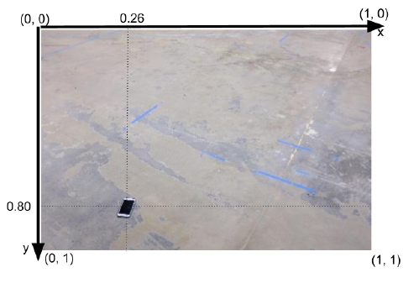

The XY-coordinate system is a normalized plane for the image. Left-corner of the image being defined as (x,y) =(0,0), left-bottom as (x,y) =(0,1), right -top as (x,y) = (1,0), and finally right-bottom corner as (x,y) = (1,1).

Your “phone detector” has to find normalized coordinates of the center of the phone. In the example above, the coordinates of the phone are approximately (x,y) = (0.26, 0.80). Every image contains a phone.

The dataset provided consists of approximately 100 jpeg images of the floor from the factory building with a phone on it. There is a file name labels.txt that contains normalized coordinates of a phone for each picture. Each line of the labels.txt is composed of img_path, x, y separated by spaces:

Img_path, x (coordinate of the phoen), y (coordinate of the phone)

Here is an example of the first 2 lines from labels.txt:

51.jpg 0.2388 0.6012

95.jpg 0.2551 0.3129

The images and labels.txt are in the ‘ find_phone ’ folder in the archive attached to this

description.

SUBMISSION FORM AND EVALUATION CRITERIA:

Please submit two executable python3 scripts.

* *train_phone_finder.py*

Takes a single command line argument or which is a path to a

folder with labeled images and labels.txt that has been attached to this

description. This script may generate any artifacts you want in the current folder.

Here is what a terminal command will look like:

* + python train_phone_finder.py ~/find_phone
* *find_phone.py*

Takes a single command line argument which is a path to the jpeg

image to be tested. This script may use data in the local folder previously

generated by *train_phone_finder.py* . This script has to print the normalized

coordinates of the phone detected on this test image in the format shown below.

Here is what a terminal command will look like. Please, notice space separated

float numbers on a **single line without parentheses**:

* + python find_phone.py ~/find_phone_test_images/51.jpg

0.2551 0.3129

You may submit any other data or library code in the same folder with these two scripts.

We understand that the labeled dataset is quite small and that certain machine learning

methods will not work reliably with such a small dataset. Therefore, you are allowed to use

absolutely **any** method for detecting phone positions that you feel is suited to the problem.

You are allowed to use any web resources or other materials like publicly available code

samples. For example, you can use any state-of-art method that you are aware about. You may use any python3 libraries provided they can be installed via *pip* package manager (including *opencv)* .

A phone is considered to be detected correctly on a test image if your output is within a

radius of 0.05 (normalized distance) centered on the phone.

NOTE

* Perfect detection performance is not the main goal of this test.
* For this prototype your algorithm is expected to detect a phone correctly on 3 out of the 8 test images and to detect at least 70% correctly on the provided labeled dataset.
* If you do not have enough time, please focus on a submission with clean, well-structured code, rather than on the perfect performance.
* Method of approach, algorithm and code will be given higher weightage.

Additionally, you are welcome to attach your notes regarding possible next steps for your

detector and ways to improve the data collection of the customer, and screenshot/ description of the evaluation metrics, if you have used any.

Good luck!